**Computer Science**

**Project File**

**Title: “Real Estate”**

Name: **Abhyuday Gaur**

Class: **XII - A**

Year: **2017-2018**

Class Roll Number : **02**

Board Roll Number:\_\_\_\_\_\_\_\_\_\_\_

Group Members:

* **Abhyuday Gaur**
* **Nakshtra Sharma**
* **Parv Jain**

# 

# Acknowledgement

**I are greatly thankful to my teacher,**

Mrs. Urvashi Singhal

**HOD Computer Science** who helped me throughout my project clearing my doubts and helping me to pass through all the hurdles and providing me consistent guidance and support.

**Student’s Signature Mrs. Urvashi Singhal**

**Name: ……………………. (HOD Computer Science)**

**j0437958j0437958dd01777_**

**Abhyuday Gaur**

TO MY SATISFACTION for the session 2017 - 2018

REAL ESTATE

Certificate of

completion

Signature

of student

signature of teacher

of class XII-A, has, successfully submitted his project on the project titled

This is to certify that

Contents

[Acknowledgement 1](#_Toc491525821)

[Overview of C++ 5](#_Toc491525822)

[Hardware and Software Requirements 7](#_Toc491525823)

[Header Files Used 8](#_Toc491525824)

[Loops 8](#_Toc491525825)

[User-Defined Functions 10](#_Toc491525826)

[Flow Chart 11](#_Toc491525827)

[Source Code 12](#_Toc491525828)

[Bibliography 53](#_Toc491525829)

# Overview of C++

C++ is a general-purpose programming language. It has imperative, object-oriented and generic programming features, while also providing the facilities for low-level memory manipulation. It is designed with a bias toward system programming with performance, efficiency and flexibility of use as its design requirements. C-HP has also been found useful in many other contexts, including desktop applications, servers, performance-s critical,

and entertainment software. C++ is r a compiled language, with implementations of it available on many platforms and provided by various organizations, including the FSF, LLVM, Microsoft and Intel.

**Real Estate Agency:** A real estate management program

**AIM OF THE PROJECT:**

In this program we have created a management program for a real estate agency through which a person can book a flat, view information about the flat, cancel a booking and also get to know about the company. Moreover the company can view the details about the booked flats.

# Hardware and Software Requirements

**Hardware:**

* **Intel® Core™ i5-5200U Processor**
* **8.00 GB RAM**
* **HP Deskjet 3635**

**Software:**

* **Turbo C++**
* **Notepad++**
* **MS Word 2016**
* **Windows 10 64-bit**

# Header Files Used

**The Header Files used are as following:**

* fstream.h
* conio.h
* process.h
* stdio.h
* stdlib.h
* ctype.h
* string.h
* dos.h

# Loops

Loops have been used to check the data entered and check their validity such as 10-digit phone number and if wrong then the user is told to re- enter the data. Loops have also been used to check avaibility of the flats. A loop has been defined to ask the user after every task about whether he wants to continue or not.

# User-Defined Functions

* Several user defined functions have been made for use in the program.
* Function flat() has been defined for keeping track of number of flats for each type of flat.
* Function info(), onebhk(), twobhk(), threebhk() have been defined for storing information about the flats.
* Function reg(), reg1(), reg2(), reg3(), have been defined for registration of flats and storing user input data.
* Function display(), disp1(), disp2(), disp3() have been defined to display information about the booked flats and flats in general.
* Function parflat(),search1(), search2(), search3() have been defined to display information about a particular booked flat.
* Function cancel(), cancel1(), cancel2(), cancel3() have been defined to cancel a booked flat.
* Function company() has been defined to display the information about the company.

# Flow Chart

# Source Code

**“Real Estate”**

// ... ... ... REAL ESTATE PROJECT ... ... ... //

#include<fstream.h>

#include<conio.h>

#include<process.h>

#include<stdio.h>

#include<stdlib.h>

#include<ctype.h>

#include<string.h>

#include<dos.h>

//............CLASS FOR FLAT............ class flat

{

char name[30], address[100], occupation[20];

char phone[11];

int flatno;

int no1,no2,no3;

public:

flat()

{

no1=300; no2=300; no3=300;

}

void setflatno(int x)

{

flatno=x;

}

void setno1()

{

no1=no1-1;

}

void setno2()

{

no2=no2-1;

}

void setno3()

{

no3=no3-1;

}

int retsetno1()

{

return no1;

}

int retsetno2()

{

return no2;

}

int retsetno3()

{

return no3;

}

//.......TO GET DETAILS FROM USER....//

void getdata()

{

cout<<"\nEnter Name: "; gets(name); cout<<"\nEnter Address: "; gets(address);

cout<<"\nEnter Mobile Number: ";

gets(phone);

while(strlen(phone)!=10)

{

cout<<"\nPhone number should be of 10 digits";

cout<<"\Enter phone number again: ";

gets(phone);

}

for(int i=0; i<10; i++)

{

if(!isdigit(phone[i]))

{

cout<<"\nPhone number should"; cout<<" contain digits only"; cout<<"\nEnter phone number again: "; gets(phone);

}

}

cout<<"\nEnter Occupation:";

gets(occupation);

for(i=0; i<strlen(occupation); i++)

{

if(!isalpha(occupation[i]))

{

cout<<"\nOccupation should"; cout<<" contain alphabets only"; cout<<"\nEnter occupation again: ";

gets(occupation);

}

}

}

//.....TO SHOW DETAILS.....//

void show()

{

cout<<"\nName: "<<name; cout<<"\nAddress: "<<address; cout<<"\nMobile number: "<<phone; cout<<"\nOccupation: "<<occupation; cout<<"\nFlat Number: "<<flatno;

}

//.....TO RETURN FLAT NUMBER.....//

int retflatno()

{

return flatno;

}

};

//.....INFORMATION ABOUT 1 BHK FLAT.....//

void onebhk()

{ flat f;

ifstream fin("one.dat",ios::in|ios::binary); cout<<"\n\t\tONE BHK FLAT"; cout<<"\n\n\tNumber of halls=1"; cout<<"\n\tNumber of bedrooms=1"; cout<<"\n\tNumber of kitchens=1"; cout<<"\n\tArea of flat= 1600 sq ft"; cout<<"\n\tPrice= Rs.7500000"; while(fin.read((char \*)&f,sizeof(f)))

{

cout<<"\n\tNumber of flats available="<<f.retsetno1();

fin.close();

}

//.....INFORMATION ABOUT 2 BHK FLAT.....//

void twobhk()

{ flat f;

ifstream fin("two.dat",ios::in|ios::binary); cout<<"\n\t\tTWO BHK FLAT"; cout<<"\n\n\tNumber of halls=1"; cout<<"\n\tNumber of bedrooms=2"; cout<<"\n\tNumber of kitchens=1"; cout<<"\n\tArea of flat= 2500 sq ft";

cout<<"\n\tPrice= Rs.20000000";

while(fin.read((char \*)&f,sizeof(f)))

{

cout<<"\nNumber of flats available="<<f.retsetno2();

fin.close();

}

//.....INFORMATION ABOUT 3 BHK FLAT.....//

void threebhk()

{ flat f;

ifstream fin("three.dat",ios::in|ios::binary); cout<<"\n\t\tTHREE BHK FLAT"; cout<<"\n\n\tNumber of halls=1"; cout<<"\n\tNumber of bedrooms=3"; cout<<"\n\tNumber of kitchens=1"; cout<<"\n\tArea of flat= 5000 sq ft"; cout<<"\n\tPrice= Rs.45000000"; while(fin.read((char \*)&f,sizeof(f)))

{

cout<<"\nNumber of flats available="<<f.retsetno3();

fin.close();

}

//......INFORMATION ABOUT FLATS......//

void info()

{

clrscr(); cout<<"\nInformation:\n"; int ch1;

cout<<"\n1 : Information about 1 bhk";

cout<<"\n2 : Information about 2 bhk"; cout<<"\n3 : Information about 3 bhk"; cout<<"\n\nEnter your choice : "; cin>>ch1;

switch(ch1)

{

case 1: onebhk();

break;

case 2: twobhk();

break;

case 3: threebhk();

break;

default: cout<<"\nWrong Choice";

}

return;

}

//.....FUNCTION FOR REGISTRATION OF 1 BHK FLAT.....//

void reg1()

{

flat one;

ifstream fin;

fin.open("one.dat", ios::binary|ios::in);

int x=0, a=0, i;

while(fin.read((char \*)&one, sizeof(flat)))

{

}

if(x<300)

{

x= one.retflatno();

x++; one.setflatno(x); one.setno1(); fin.close();

cout<<"\nEnter details for registration\n";

one.getdata();

cout<<"\n\nFlat Registered\n";

}

else

{

cout<<"\nFlat No="<<x;

ofstream fout;

fout.open("one.dat", ios::binary|ios::app); fout.write((char \*)&one,sizeof(flat)); fout.close();

cout<<"\n\nSORRY... No more flats available...!!!"”;

getch();

return;

}

//.....FUNCTION FOR REGISTRATION OF 2 BHK FLAT.....//

void reg2()

{

flat two;

cout<<"\nEnter details for registration\n";

ifstream fin;

fin.open("two.dat", ios::binary|ios::in);

int x=0;

while(fin.read((char \*)&two, sizeof(flat)))

{

x=two.retflatno();

}

If(x<300)

{

x++;

{

x++;

two.setflatno(x);

two.setno2();

fin.close();

two.getdata();

cout<<”\n\nFlat Registered \n”;

cout<<”\nFlat No=”<<x;

ofstream fout;

fout.open(“two.dat”,ios::binary|ios::app);

fout.write((char\*)&two.sizeof(flat));

fout.close();

}else

{

Cout<<”\n\n Sorry, No more flats available.”;

}

getch();

return;

//.....FUNCTION FOR REGISTRATION OF 3 BHK FLAT.....//

void reg3()

{

flat three;

cout<<"\nEnter details for registration\n";

ifstream fin;

fin.open("three.dat", ios::binary|ios::in);

int x=0;

while(fin.read((char \*)&three, sizeof(flat)))

{

}

if(x<300)

{

x= three.retflatno();

x++; three.setflatno(x); three.setno3(); fin.close(); three.getdata();

cout<<"\n\nFlat Registered\n";

cout<<”\nFlat No=”<<x;

ofstream fout;

fout.open(“three.dat,”ios::binary|ios::app);

fout.write((char \*)&three,sizeof(flat));

fout.close();

}

else

{

cout<<"\n\nSORRY... No more flats available.”;

}

getch();

return();

}

//......FUNCTION FOR REGISTRATION......//

void reg()

{

clrscr(); cout<<"\nRegistration:\n"; char num;

cout<<"\nEnter flat to be registered(1/2/3 bhk)= ";

cin>>num;

switch (num)

{

fin.open("one.dat", ios::binary);

if(!fin)

{

cout<<"\nError in displaying details";

return;

}

flat temp;

}

{

case '1': reg1();

break;

case '2': reg2();

break;

case '3': reg3();

break;

default : cout<<"\nWrong Chgoice!!";

}

return;

}

//.....FUNCTION TO DISPLAY DETAILS OF 1 BHK FLAT.....//

void disp1()

{

ifstream fin;

while(fin.read((char\*)&temp, sizeof(temp)))

{

cout<<endl;

temp.show();

}

fin.close();

}

//.....FUNCTION TO DISPLAY DETAILS OF 2 BHK FLAT.....//

void disp2()

{

ifstream fin;

fin.open("two.dat", ios::binary);

if(!fin)

{

cout<<"\nError in displaying details";

return;

}

flat temp;

while(fin.read((char\*)&temp, sizeof(temp)))

{

cout<<endl;

temp.show();

}

fin.close();

}

//.....FUNCTION TO DISPLAY DETAILS OF 3 BHK FLAT.....//

void disp3()

{

ifstream fin;

fin.open("three.dat", ios::binary);

if(!fin)

{

cout<<"\nError in displaying details";

return;

}

flat temp;

while(fin.read((char\*)&temp, sizeof(temp)))

{

cout<<endl;

temp.show();

}

fin.close();

}

//......FUNCTION TO DISPLAY DETAILS OF FLATS BOOKED......//

void display()

{

clrscr();

char num;

cout<<"\nDisplaying Details:\n";

cout<<"\nEnter flat type whose details have to be displayed(1/2/3)= ";

cin>>num;

switch (num)

{

case '1': disp1();

break;

case '2': disp2();

break;

case '3': disp3();

break;

default: cout<<"\nWrong Choice!!";

}

return;

}

//.....FUNCTION TO DISPLAY DETAILS OF A PARTICULAR 1 BHK FLAT.....//

void search1(int fnum)

{

ifstream fin;

flat temp;

fin.open("one.dat", ios::binary);

int f=0;

if(!fin)

{

cout<<"\nError!!!!";

return;

}

while(fin.read((char\*)&temp, sizeof(temp)))

{

if(temp.retflatno()==fnum)

{

temp.show();

f=1;

}

}

if(f==0)

cout<<"\nThis flat is not booked yet!!";

return;

}

//.....FUNCTION TO DISPLAY DETAILS OF A PARTICULAR 2 BHK FLAT.....//

void search2(int fnum)

{

ifstream fin;

flat temp;

fin.open("two.dat", ios::binary);

int f=0;

if(!fin)

{

cout<<"\nError!!!!";

return;

}

while(fin.read((char\*)&temp, sizeof(temp)))

{

if(temp.retflatno()==fnum)

{

temp.show();

f=1;

}

}

if(f==0)

cout<<"\nThis flat is not booked yet!!";

return;

}

//.......FUNCTION TO DISPLAY DETAILS OF A PARTICULAR THREE BHK FLAT......

void search3(int fnum)

{

ifstream fin;

flat temp;

fin.open("three.dat", ios::binary);

int f=0;

if(!fin)

{

cout<<"\nError!!!!";

return;

}

while(fin.read((char\*)&temp, sizeof(temp)))

{

if(temp.retflatno()==fnum)

{

temp.show();

f=1;

}

}

if(f==0)

cout<<"\nThis flat is not booked yet!!";

return;

}

//......FUNCTION TO DISPLAY DETAILS OF A PARTICULAR FLAT.........

void parflat()

{

clrscr();

int flatnum,no;

cout<<"\nShowing Particular Details:\n"; cout<<"\nEnter type of flat(1/2/3 bhk):"; cin>>no;

if(no==1||no==2||no==3)

{

cout<<"\n\nEnter the flat number whose details";

cout<<" you want to see:";

cin>>flatnum;

switch(no)

{

ase 1:search1(flatnum);

break;

case 2:search2(flatnum);

break;

case 3:search3(flatnum);

break;

}

}

else

{

Cout<<”\nWrong choice!”;

}

}

cout<<"\nWrong choice!!";

}

}

//......FUNCTION TO CANCEL A ONE BHK FLAT.... void cancel1()

{

ifstream fin;

int flatnum,f=0; flat tem; ofstream fout;

fin.open("one.dat",ios::binary);

fout.open("temp.dat",ios::binary|ios::app);

if(!fin)

{

cout<<"\nError!!";

getch();

return;

}

cout<<"\n\nEnter flat number to be cancelled:"; cin>>flatnum; while(fin.read((char\*)&tem,sizeof(tem)))

{

if(tem.retflatno()!=flatnum)

{

}

else

{

f=1;

}

}

fout.write((char\*)&tem,sizeof(tem));

fin.close();

fout.close();

remove("one.dat"); rename("temp.dat","one.dat"); if(f==0)

{

cout<<"\n Flat not booked yet";

getch();

}

else

{

cout<<"\nThe flat has been cancelled";

}

getch();

}

//..FUNCTION TO CANCEL A TWO BHK FLAT........ void cancel2()

{

ifstream fin;

int flatnum,f=0; flat tem; ofstream fout;

fin.open("two.dat",ios::binary);

fout.open("temp.dat",ios::binary|ios::app);

rename("temp.dat","two.dat");

if(f==0)

{

cout<<"\n Flat not booked yet";

getch();

}

else

{

cout<<"\nThe flat has been cancelled";

}

getch();

}

//.......FUNCTION TO CANCEL A THREE BHK FLAT........ void cancel3()

{

ifstream fin;

int flatnum,f=0; flat tem; ofstream fout;

fin.open("three.dat",ios::binary); fout.open("temp.dat",ios::binary|ios::app); if(!fin)

{

if(f==0)

{

cout<<"\nError!!";

getch();

return;

}

cout<<"\n\nEnter flat number to be cancelled:"; cin>>flatnum; while(fin.read((char\*)&tem,sizeof(tem)))

{

if(tem.retflatno()!=flatnum)

{

fout.write((char\*)&tem,sizeof(tem));

}

else

{

f=1;

}

}

fin.close(); fout.close(); remove("three.dat"); rename("temp.dat","three.dat");

{

cout<<"\n Flat not booked yet";

getch();

}

else

{

cout<<"\nThe flat has been cancelled";

}

getch();

}

//......function for cancellation of flat......... void cancel()

{

clrscr();

int type;

cout<<"\nFor Cancellation:\n";

cout<<"\nEnter the type of flat to be cancelled(1/2/3)= ";

cin>>type;

if(type==1||type==2||type==3)

{

switch(type)

{

}

}

else

{

case 1:cancel1();

break;

case 2:cancel2();

break;

case 3:cancel3();

break;

cout<<"\nWrong choice!!....";

}

}

//...........FUNCTION TO DISPLAY DETAILS OF COMPANY.........//

void company()

clrscr();

cout<<"\n\n\n\tDetails of our company:\n";

gotoxy(10,10);

cout<<"\n\t\t\t APN CO. is a profitable company founded by ";

cout<<"\n\t\t Abhyuday Gaur ";

cout<<"and Nakshtra Sharma and\n\t\t\t Parv Jain";

cout<<"\n\t\t\t in the year 2017 with ";

cout<<"\n\t a view of providing quality affordably,which were ";

cout<<"\n\t essentially missing for a middle and upper class ";

cout<<"\n\t families.APN housing society is one of the top names ";

cout<<"\n\t\t in the field of real estate. ";

getch();

}

//.............MAIN FUNCTION.................. void main()

{

//textcolor(WHITE);

//textbackground(BLACK);

clrscr(); char ch; int ch2; do

{

clrscr();

cout<<"\n\n\n\n Welcome To A P N \n\n\n\n”;

cout<<"\n\n"; system("pause"); clrscr();

cout<<"\n\t\t\t\*\*\*\*\*WELCOME TO APN CITY\*\*\*\*\*"; cout<<"\n\n\tSELECT YOUR CHOICE\n\n"; cout<<"\n\t\t1:Details of Our Company"; cout<<"\n\t\t2:Information about Flats"; cout<<"\n\t\t3:Book Flats"; cout<<"\n\t\t4:Display Details of Flats Booked"; cout<<"\n\t\t5:Show Particular Details of a Flat"; cout<<"\n\t\t6:For Cancellation of Flat"; cout<<"\n\t\t7:Exit";

cout<<"\n\t\t\tEnter Your Choice: ";

cin>>ch2;

switch(ch2)

{

case 1: company();

break;

case 2: info();

break;

case 3: reg();

break;

case 4: display();

break;

case 5: parflat();

break;

case 6: cancel();

break; case 7:exit(0); default:cout<<"\nWrong choice!!";

break;

}

cout<<"\n\nDo you want to continue(y/n) ? ";

cin>>ch;

}while(ch=='y'||ch=='Y');

getch();

}

**OUTPUT OF THE PROGRAM**

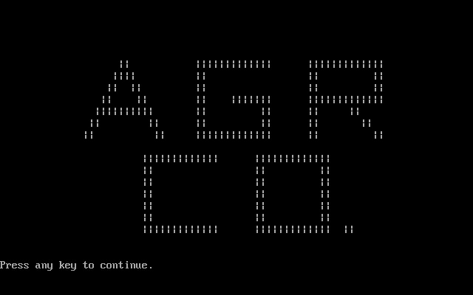

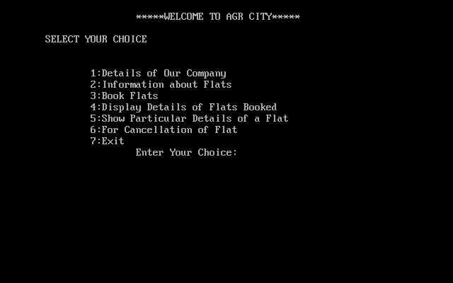

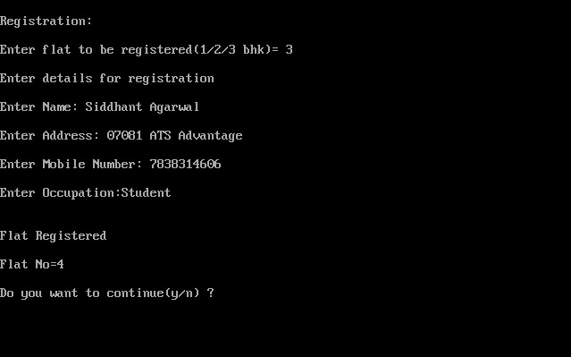

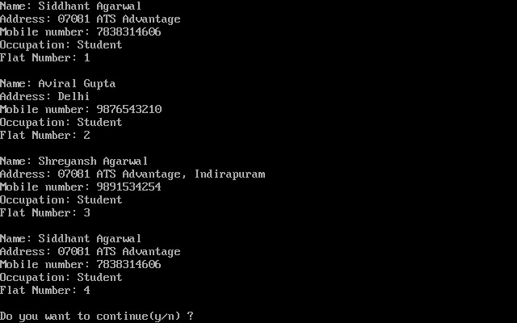

# Bibliography

* **Computer Science with C++, Class XII by Sumita Arora**
* **Uravashi Ma’am’s Teachings**
* **www.google.com**
* **www.cplusplus.com**